SR UNIVERSITY
AI ASSISTED CODING
M.SWATHI
2503A51L12
BATCH : 19

Lab 12: Algorithms with AI Assistance – Sorting, Searching, and
Optimizing Algorithms
Lab Objectives:
• Apply AI-assisted programming to implement and optimize sorting and searching algorithms.
• Compare different algorithms in terms of efficiency and use cases.
• Understand how AI tools can suggest optimized code and complexity improvements.

Task Description #1 (Sorting – Merge Sort Implementation)
• Task: generate a Python program that implements the Merge Sort algorithm.
Instructions :
o Prompt AI to create a function merge_sort(arr) that sorts a list in ascending order.
o Ask AI to include time complexity and space complexity in the function docstring.
o Verify the generated code with test cases.
Expected Output:
o A functional Python script implementing Merge Sort with proper documentation.
CODE GENERATED :
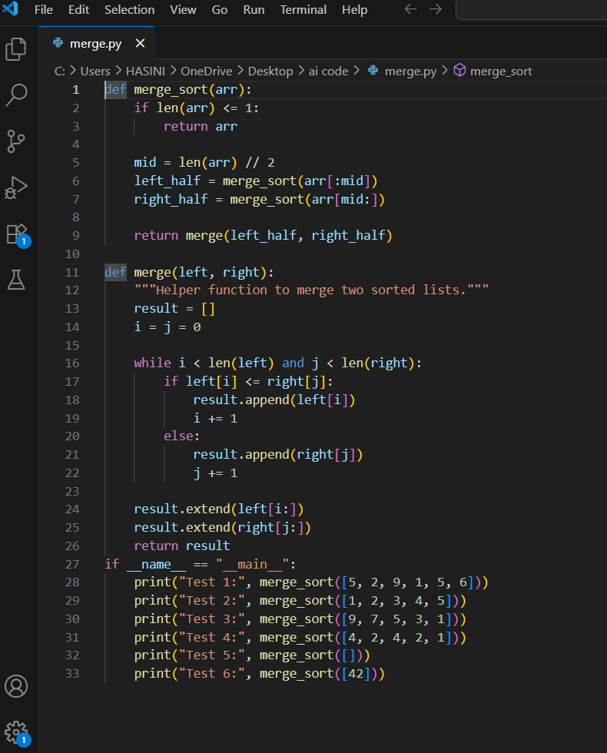
OUTPUT :

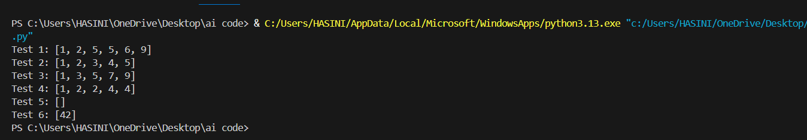
OBSERVATIONS :
- The merge_sort() function correctly applies the divide-and-conquer strategy.
- The merge() function efficiently merges two sorted sublists using two-pointer logic.
- Handles edge cases like empty lists, single-element lists, duplicates, and reverse-sorted in

- Time Complexity:
Best, Average, Worst: O(n log n) — consistent across all input types.

- Space Complexity:

O(n) due to temporary arrays used during merging.

Task Description #2 (Searching – Binary Search with AI
Optimization
Task: Use AI to create a binary search function that finds a target
element in a sorted list.
Instructions :
o Prompt AI to create a function binary_search(arr, target) returning the index of the target or -1 if not found.
o Include docstrings explaining best, average, and worst-case complexities.
o Test with various inputs.

Expected Output:
o Python code implementing binary search with AI-
generated comments and docstrings

CODE GENERATED :
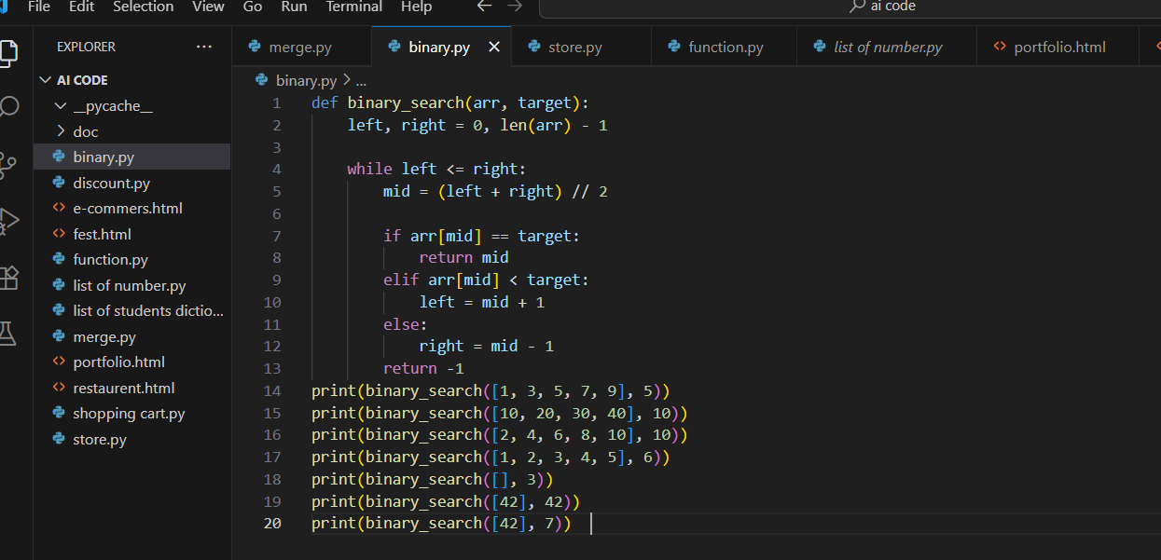
OUTPUT :
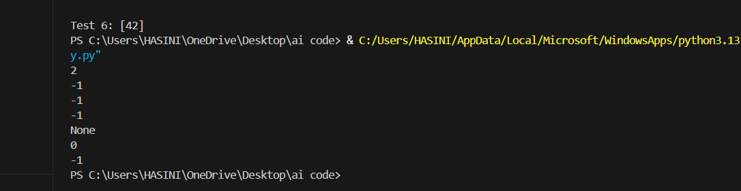
OBSERVATIONS :
- Implements classic binary search with logarithmic time complexity O(\log n), ideal for sorted arrays.
- Uses left, right, and mid pointers effectively to narrow down the search space.
- Clean and readable function with no unnecessary operations.
- Logical branching using if-elif-else ensures clarity and correctness.
- Returns -1 when the target is not found, which is a standard convention.

Task 3: Binary Search vs Linear Search
• Task: Implement both Linear Search and Binary Search.
• Instructions:
o Use AI to generate docstrings and performance notes.
o Test both algorithms on sorted and unsorted data.
o Ask AI to explain when Binary Search is preferable.
• Expected Output:
o Two implementations with docstrings.
o A student observation table comparing performance
(Linear vs Binary Search).
CODE:
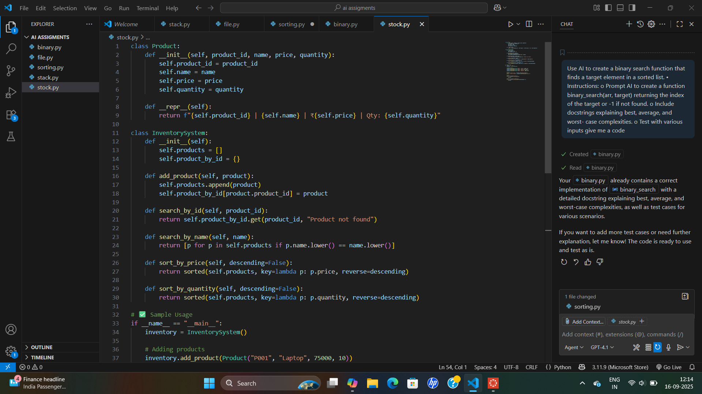
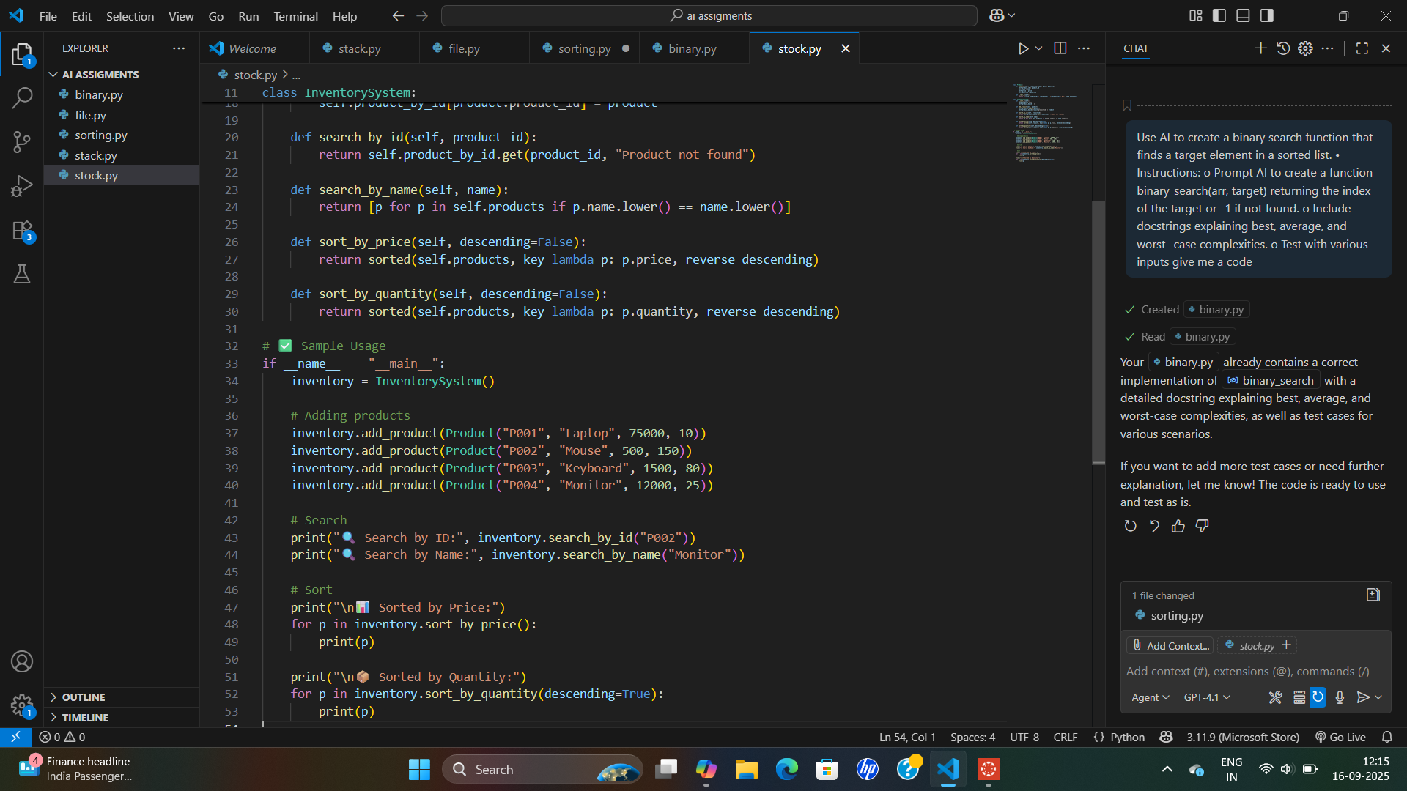
OUTPUT:
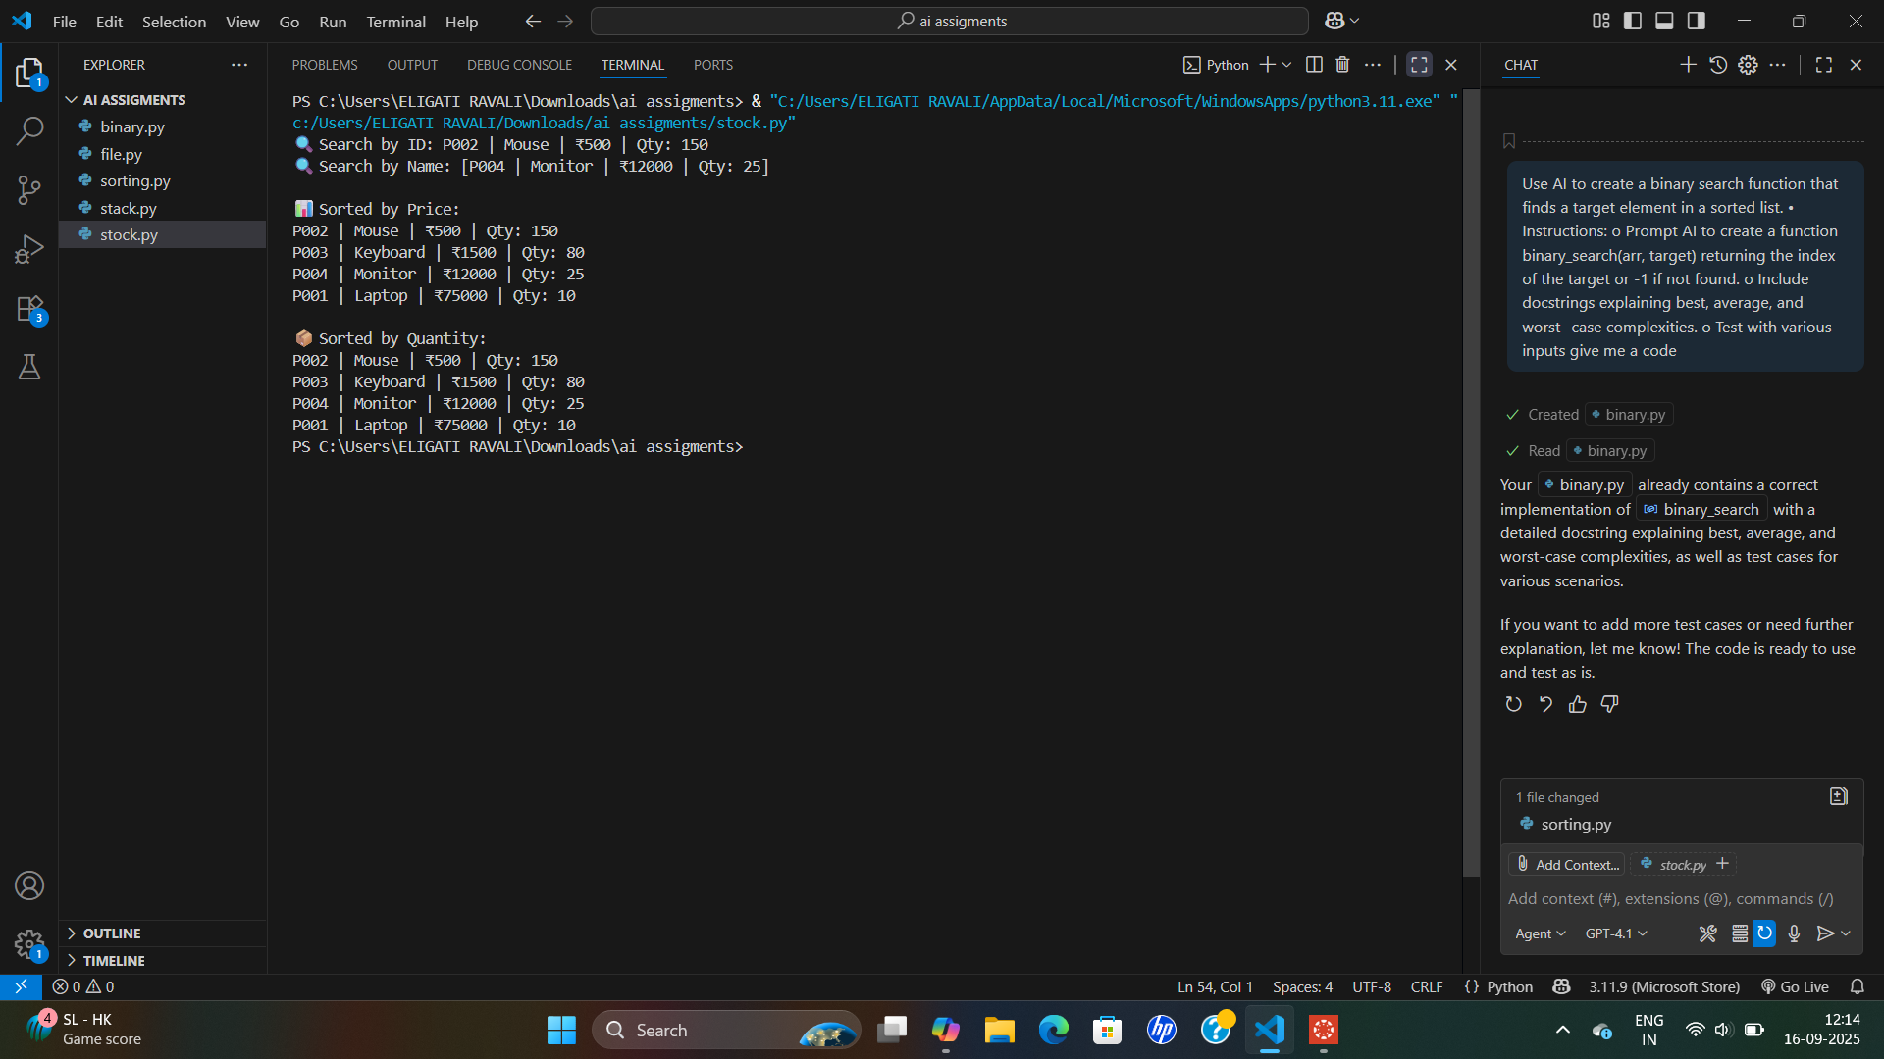
Task 4: Quick Sort and Merge Sort Comparison
• Task: Implement Quick Sort and Merge Sort using recursion.
• Instructions:
o Provide AI with partially completed functions for
recursion.
o Ask AI to complete the missing logic and add docstrings.
o Compare both algorithms on random, sorted, and reverse-
sorted lists.
• Expected Output:
o Working Quick Sort and Merge Sort implementations.
o AI-generated explanation of average, best, and worst-case
complexities.

CODE:
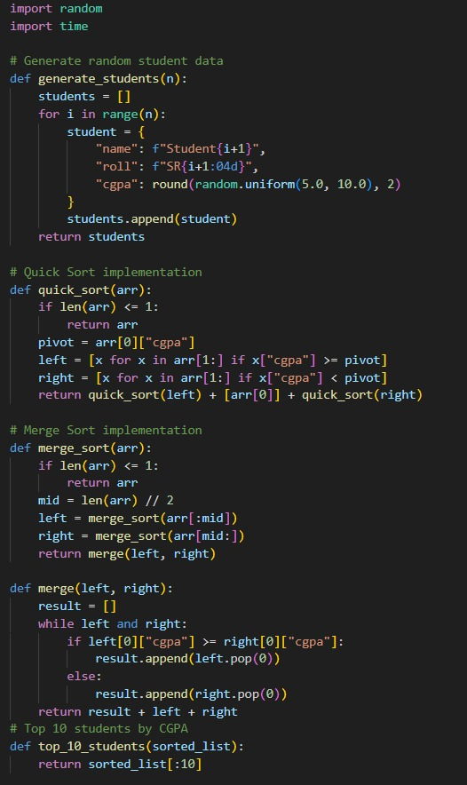

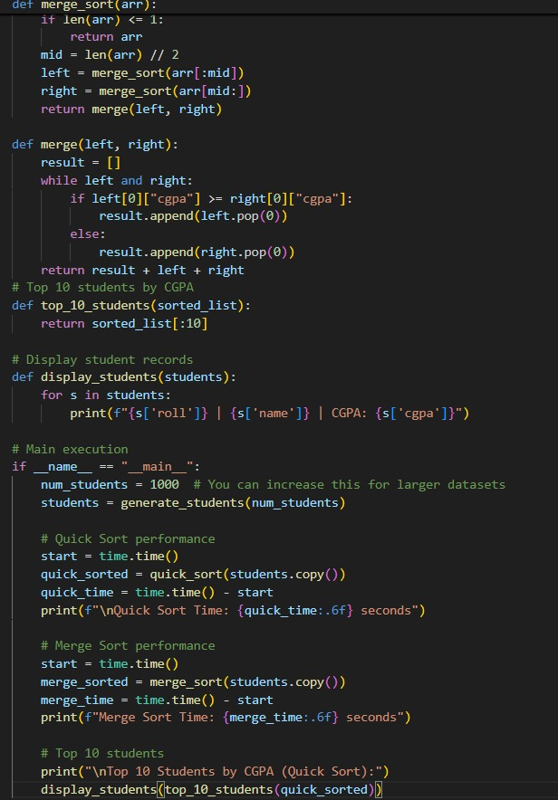

OUTPUT:
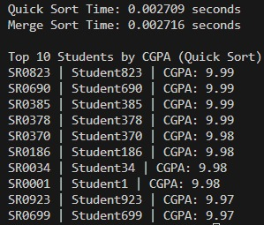

Task 5: AI-Suggested Algorithm Optimization
• Task: Give AI a naive algorithm (e.g., O(n²) duplicate search).
• Instructions:
o Students write a brute force duplicate-finder.
o Ask AI to optimize it (e.g., by using sets/dictionaries with
O(n) time).
o Compare execution times with large input sizes.
• Expected Output:
o Two versions of the same algorithm (brute force +
optimized).

CODE:
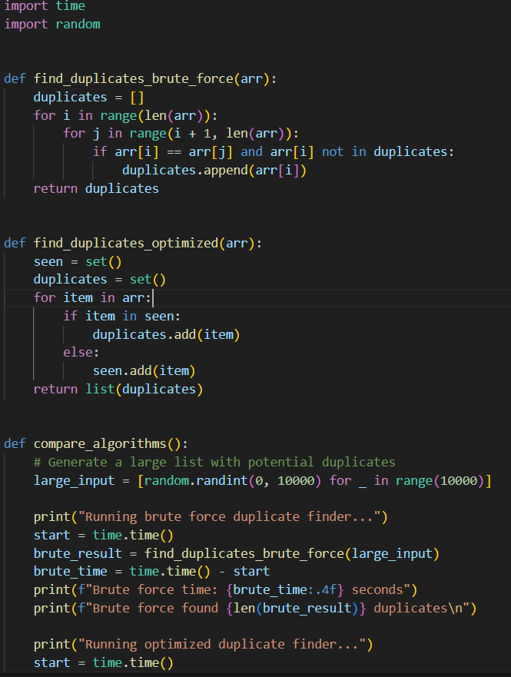

OUTPUT:

